JAN – MARCH, 2025 (EVENT UPDATES)

PATIENT STORY – ROHINI BHATIA

Rohini Bhatia’s journey took a difficult turn when she was diagnosed with Embryonal Rhabdomyosarcoma, a life-threatening condition that placed an immense financial strain on her family. Her father, a barber earning just ₹6,000 per month, struggled to afford the costly treatment while her mother is a housewife. Referred to HCG Foundation by Dr. Krisha Shah, hope emerged as the foundation stepped in to cover the expenses of her chemotherapy and radiation therapy. With this crucial support, Rohini continues her fight with courage, surrounded by the care and compassion that is making her recovery possible

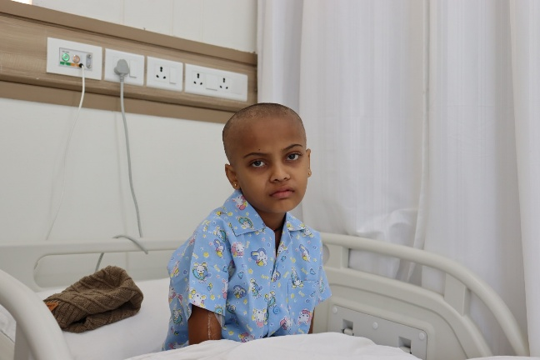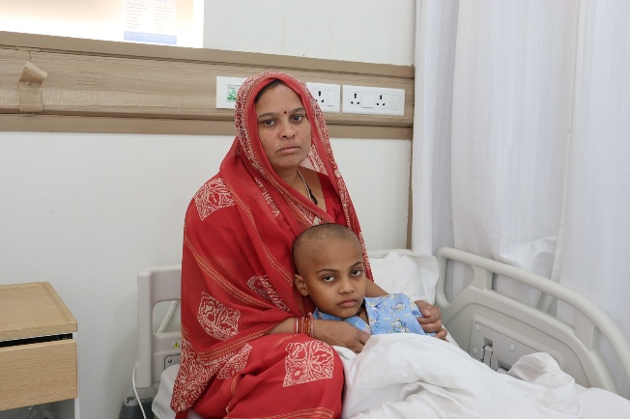

A NIGHT OF HOPE
HCG Foundation hosted a special fundraising screening of the inspiring movie Umbarro at YMCA, bringing together around 60 participants, including doctors, cancer winners, and supporters. The evening was a powerful testament to resilience, hope, and the strength of community in the fight against cancer.

Through this initiative, attendees not only witnessed a story of courage but also reinforced their commitment to spreading awareness and supporting those affected. The event fostered meaningful conversations, ignited hope, and emphasized the importance of early detection and care. HCG Foundation remains dedicated to making a difference, standing united in the fight against cancer.
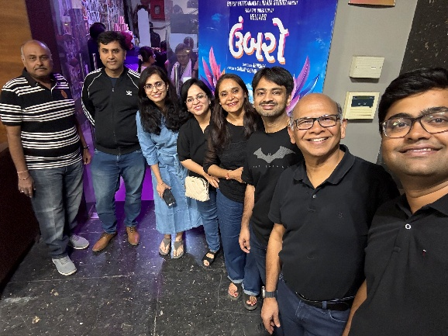

CHILDHOOD CANCER DAY CELEBRATION
HCG Foundation, in collaboration with Access Life Foundation, marked Childhood Cancer Day with a day full of learning and joy! Dr. Krisha Shah, Pediatric Oncologist at HACC, delivered an insightful health talk on Health & Hygiene. The little warriors then unleashed their creativity through drawing activities, followed by a heart-warming gift distribution.
Together, we stand for awareness, care, and a brighter future for these brave young souls!

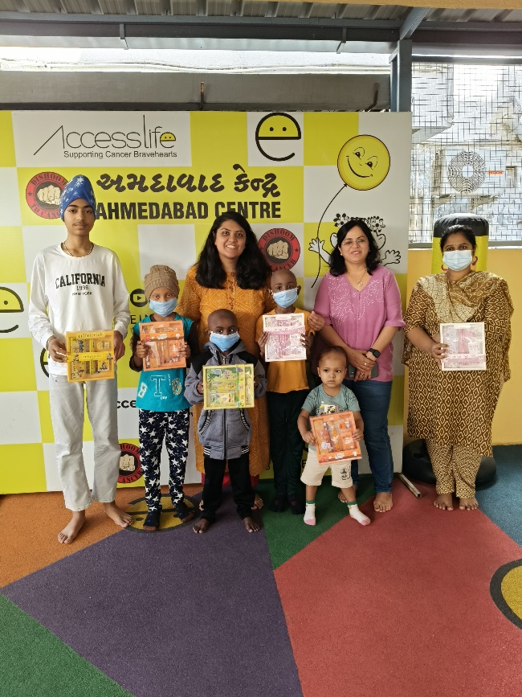

CHILDHOOD CANCER DAY CELEBRATION – BANGALORE
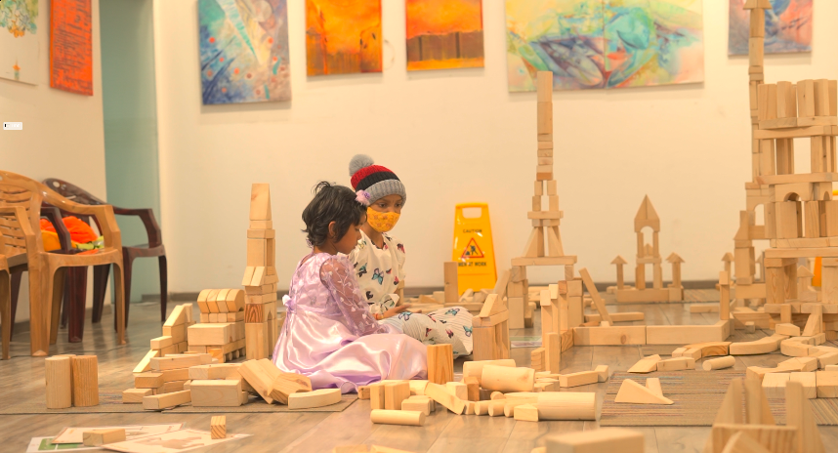

Together for the Fighters – Honouring Childhood Cancer Day

A beautiful celebration of strength, courage, and hope unfolded on Childhood Cancer Day, conducted at Swasti Art Gallery in collaboration with TROY. Children undergoing treatment came together in a joyful display of resilience, surrounded by the unwavering support of caregivers, doctors, and volunteers. The atmosphere was filled with music, dance, laughter, and love — reminding us of all that even in the face of adversity, the spirit of childhood shines brightly.
Let’s continue to stand by these young warriors, raise awareness, and be a part of their journey toward healing.

LYMPHEDEMA AWARENESS SESSION
HCG Foundation, in collaboration with HCG Aastha Cancer & Being Patient Foundation, successfully organized a Lymphedema Awareness Session on March 3rd at HCG Aastha Cancer Centre. The event brought together 100+ attendees, including JG College students, doctors, patients, and HCG staff, fostering awareness and support for those affected by lymphedema.

Key Highlights of the Event:
- Dr. Steffi Alphonso led an insightful session on Lymphedema Awareness
- Dr. D G Vijay & Dr. Tanay shared valuable knowledge on the condition
- Sudarshan Bhamare, Chief Operating Officer, and Dr. Soma Bose, Chief Medical Administrator, graced the event with their presence and support
- Free pressure garments were distributed to financially challenged cancer patients

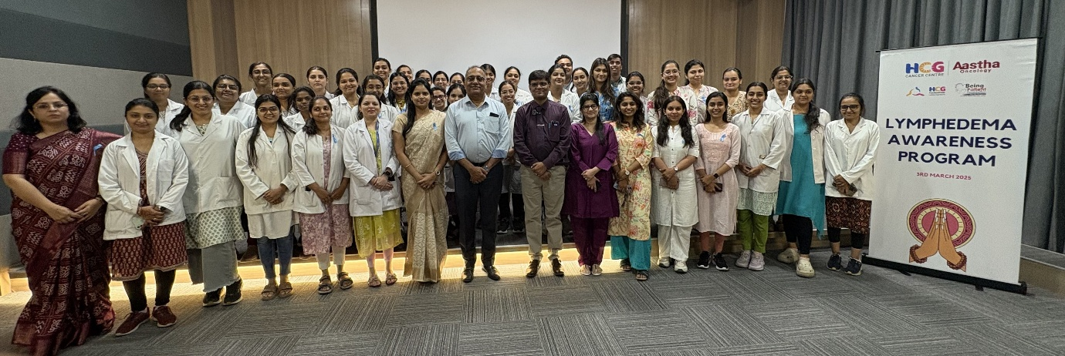

CERVICAL CANCER AWARENESS SESSION

HCG Foundation, in collaboration with HCG Aastha Cancer Centre and Iota Diagnostic Centre, organized an awareness session on Cervical Cancer Prevention & Early Detection on March 20, 2025, at HACC Auditorium.

The session witnessed active participation from 25-30 attendees across various hospital departments, reinforcing the importance of early screening and preventive care. Bhoomee Thakrar led an insightful presentation on Cervical Cancer and its prevention, emphasizing the need for timely detection.
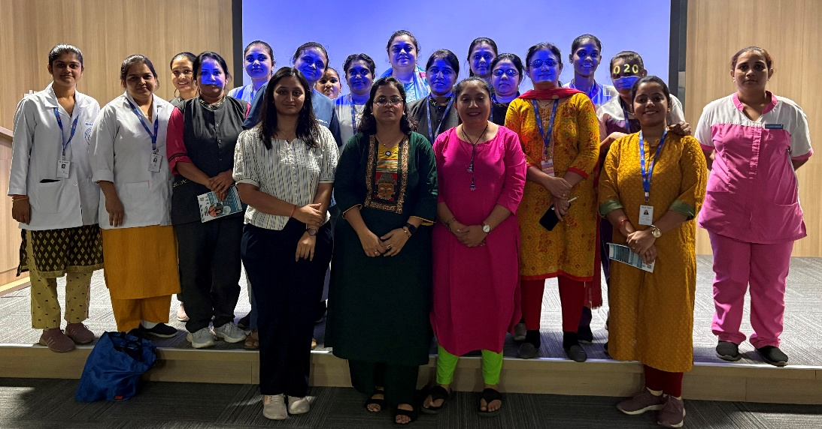

CERVICAL CANCER SCREENING CAMP
As a follow up of the Cervical Cancer Awareness Session, Pap Smear Test Camp was organized on March 22, 2025 in association with Iota Diagnostic Centre at HACC, First Floor OPD. A total of 30 staff members participated and underwent pap smear tests as part of this important health initiative.

